You will need the following information:
- Your Social Security Number
- Your Date of Birth
- Email Address
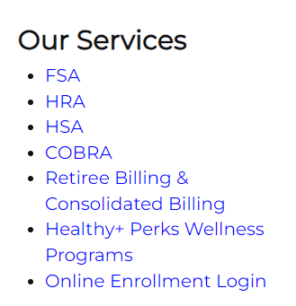
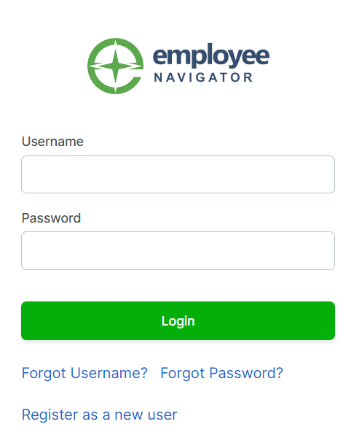
Registration and Enrollment Instructions
- Go to https://cps125.com
- Click “Online Enrollment Login”
under Our Services
- Click on “New User Registration”
- Enter in requested information.
  - Your First and Last Name
  - Company Identifier FloridaSW
  - PIN - Last 4 digits of your Social Security Number
  - Your Date of Birth (mm/dd/yyyy)
  - Click “Next”
- Set up Login
  - Set up Username (Your Email Address)
  - Set up a Password
  - Check “I agree with the terms of use”
  - Click “Next”
- Click “Start Benefits”
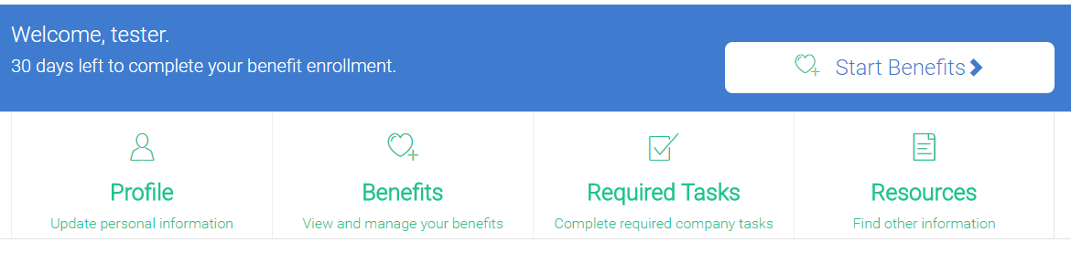
- Update Personal information
- Make your benefits election
- Enroll by 10/20/2023 (HR please update and let Eagles know)

