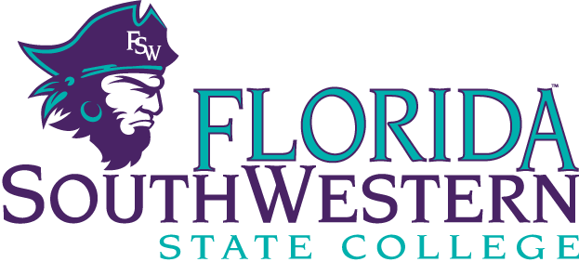
REQUESTING DEPARTMENT INFORMATION

Department: Location/Building:
Contact Person Name: Title:
Phone No: Ext:

STUDENT POSITION INFORMATION

Number of Students Being Requested:
If specific student(s) list name(s):
Work Location: Campus - Building - Room -
Supervisor Name: Supervisor Title:
Work Study Student Duties and Responsibilities:

Requestor’s Name:
Requestor’s Signature: _________________________ Date:

Submit form to the Office of Human Resources for processing of request.

Florida SouthWestern State College is committed to providing an educational and working environment free from discrimination and harassment. All programs, activities, employment and facilities of Florida SouthWestern State College are available to all on a non-discriminatory basis, without regard to race, sex, age, color, religion, national origin, ethnicity, disability, sexual orientation, marital status, genetic information or veteran's status. The College is an equal access/equal opportunity institution. Questions pertaining to educational equity, equal access, or equal opportunity should be addressed to Title IX Coordinator/Equity Officer, 8099 College Parkway, Fort Myers, FL 33919, (239) 489-9305.

