Learning Assessment Committee Meeting
10/5/2016
12:00 – 1:00
AA-168 (Lee Campus); E-105 (Charlotte Campus);
G-109 (Collier Campus); A-114 (Hendry/Glades)

Members Present: Katie Paschall, Eric Seelau, Rebecca Harris, Amy Trogan , Joe Van Gaalen, Marius Coman, Caroline Seefchak, Megan Just, Barbara Miley, Jane Charles, Richard Worch, Fernando Mayoral, Allison Studer, Lisa McGarity, Colleen Moore, Tom Donaldson, Kristi Moran, Sarah Lublink, John Connell

Members Absent: Eileen DeLuca, Elijah Pritchett, Margaret Kruger, Marty Ambrose

Guests: Kristin Corkhill, Director of Dual Enrollment

- Dual Enrollment Update
  - Kristin Corkhill introduced herself and reported there were email problems with Dual Enrollment faculty in that their status in the system causes them to be removed and therefore have no email. She reported that she had met with Dr. Miller, Dean of Education; Dr. DeLuca, AVPAA; Dr. Trogan, LAC Chair; and Dr. van Gaalen, Director of Academic Assessment in order to ensure that both course level assessment and general education assessment could move forward as smoothly as possible despite these communication issues.
  - Joe van Gaalen asked if a hard copy of the latest LAC newsletter which included the callout for General Education Assessment submissions be sent to Dual Enrollment faculty. Kristin agreed this could be done and Caroline Seefchak volunteered to make sure Kristin has a copy of the newsletter in which to make hard copies from and deliver to Dual Enrollment faculty
  - Fernando asked about professional development plans to ensure Dual Enrollment faculty are involved. Kristin noted that it would be helpful if her office knows about plans ahead of time so that they can reach out to Dual Enrollment faculty.
  - Amy noted the Speech Dept. has a great reputation working with adjuncts and Dual Enrollment and having Myra as the Professional Development Coordinator is an asset.
- September Minutes
  - Amy presented September 2, 2016 meeting minutes.
  - Tom Donaldson noted his absence in the September meeting to be included in those minutes.
  - Caroline Seefchak motioned to approve. Rebecca Harris seconded the motion. Minutes were approved.
- Amy introduced new members including Lisa McGarity from Collier Campus (Science), and interested faculty in attendance: Jennifer Patterson from SoBT, and Eric Faye from Hendry-Glades (Science).
- Joe van Gaalen reviewed the latest information on course level assessment.
  - The 2016-2017 Focus Course List for course-level assessment was presented as a work-in-progress as shown in the figure below so as to make Assessment Coordinators aware of the present working list and add/subtract as needed.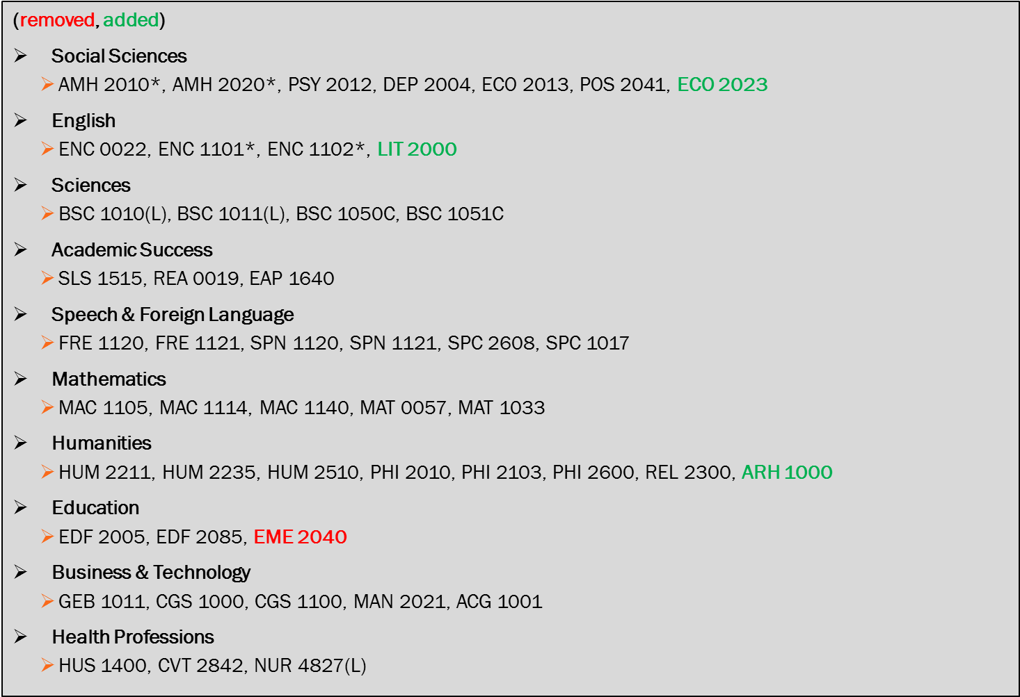
  - Black font indicates those courses which are carrying over from 2015-2016. Green indicates those which have been added for 2016-2017. Red indicates those which have been removed from 2015-2016.
  - Sarah Lublink noted that HUM 2510 should be HUM 2250 as 2510 is no longer offered. Also, MUL 1010 should be added to the focus course list.
  - Caroline Seefchak and Megan Just noted that they do have a course to replace EME 2040 and will get that information to the Office of Assessment shortly.
- Joe van Gaalen reported the current 2016-2017 plans for course level assessment according to Compliance Assist as of Oct. 3, 2016 such that coordinators can note any omissions or inclusions that need to be amended.
  - Richard Worch noted that all PAD/Law courses will continue with 100% assessment for all assignments. The department has chosen one assignment in which data will be kept separate from Canvas. Richard reported that Wendy Athens assures him that all data can be extracted from Canvas.
- Joe van Gaalen reminded the committee that the General Education Assessment Callout has been made this past week and provided the committee with the callout as seen in the September LAC Newsletter as well as the submission form as found on the webpage (https://www.fsw.edu/facultystaff/assessment/generaleducation).
- Amy Trogan reported that the next LAC Meeting will be a split meeting among the two subcommittees (General Education Assessment and Professional Development). The General Education Assessment subcommittee will meet in AA-177 during the normal LAC meeting hours. The General Education Assessment subcommittee will be led by Joe van Gaalen and will included the following members:
  - Elijah Pritchett
  - Fernando Mayoral
  - Katie Paschall
  - Rebecca Harris
  - Eric Seelau
  - Colleen Moore
  - Barbara Miley
  - Marius Coman
- Amy Trogan reported that the Professional Development subcommittee will meet in a different (as yet undetermined) room during normal LAC meeting hours. The Professional Development subcommittee will be led by Eileen DeLuca and will include the following members:
  - Richard Worch
  - Megan Just
  - Sarah Lublink
  - Jane Charles
  - Kristi Moran
  - John Connell
- Amy asked to reach out to her for contributions and content ideas for the October Assessment Newsletter. Amy suggested Rebecca Harris for the new member spotlight.
- Amy reminded the committee that the deadline for General Education (Section IV) revisions is October 21.
- Amy reminded coordinators that the following action items should be noted for your department meetings:
  - Make sure you, as the assessment coordinator, are on the dept. meeting agenda.
  - Reach out to your department for General Education submissions.
  - Reach out to your department for any final thoughts on the 2016-2017 focus course list.
  - Remind your department about the two upcoming General Education workshops “Meeting of the Minds”, preferably by email or some other means prior to your department meeting as the workshops takes place before the department meeting on the 14th.
  - Joe van Gaalen reminded committee to alert potential General Education Submission faculty to be sure to include student information numbers to allow for Value-Added studies as well as to reach out to the Office of Assessment if you have any questions regarding the General Education (Section IV) revisions.
- Amy praised group for working well together and producing great work.
- Kristi Moran noted Engdahl is no longer with FSW.

Richard Worch motioned to adjourn. Caroline Seefchak seconded.

