Learning Assessment Committee Meeting
12/2/2016
12:00 – 1:00
AA-177 (Lee Campus); E-105 (Charlotte Campus);
G-109 (Collier Campus)

Members Present: Eric Seelau, Amy Trogan , Joe Van Gaalen, Marius Coman, Caroline Seefchak, Megan Just, Barbara Miley, Jane Charles, Richard Worch, Fernando Mayoral, Allison Studer, Lisa McGarity, Colleen Moore, Tom Donaldson, Kristi Moran, Sarah Lublink, John Connell, Elijah Pritchett, Jennifer Patterson, Eric Fay

Members Absent: Katie Paschall, Eileen DeLuca, Margaret Kruger, Marty Ambrose, Rebecca Harris

- Amy Trogan called meeting to order (12:05pm)
- Amy Trogan presented October 5, 2026 meeting minutes and noted minor typos (included date to read 2016, rather than 2026). Richard Worch motioned to approve minutes as amended. Caroline Seefchak seconded the motion.
- Joe van Gaalen reviewed the latest information on Course-level assessment.
  - The 2016-2017 Focus Course List for Course-level assessment was presented in final format.
  - Richard Worch asked if course level assessment was to be reported in Compliance Assist. Joe van Gaalen reported that it has been completed by many departments.
- Joe van Gaalen reviewed the latest information on General Education Assessment.
  - As of Dec. 2, 2016, 29 Critical Thinking assignments
    - Modalities represented: 18 Face-to-face, 6 Dual enrollment, 5 Online
    - Disciplines represented: 10 English, 5 Science, 4 Social Science, 3 Cornerstone Experience, 2 Education, 2 Foreign Language, 1 Math, 1 Health Professions, and 1 Humanities
  - and 13 Scientific & Quantitative Reasoning assignments have been volunteered
    - Modalities represented: 11 Face-to-face, 0 Dual enrollment, 2 Online
    - Disciplines represented: 7 Science, 2 Social Science, 3 Math, and 1 Health Professions
- Joe van Gaalen reported on the General Education Workshop meeting (held during standard Learning Assessment Committee Meeting in November).
  - Scoring group is formed (12 members with 6 for each competency)
  - Estimated sample size for each scorer is 55-70 based on present sample size
- Amy Trogan reported that the December Newsletter will be just a holiday greeting. Kristi Moran offered some ideas for the message. Caroline Seefchak added that she will develop the greeting and well-wishing newsletter in draft form for distribution.
- Based on the Professional Development Subcommittee (which also met during standard Learning Assessment Committee Meeting in November), Joe van Gaalen developed a terminology page style (shown below) as well as sample descriptions for each (example also below.
  - 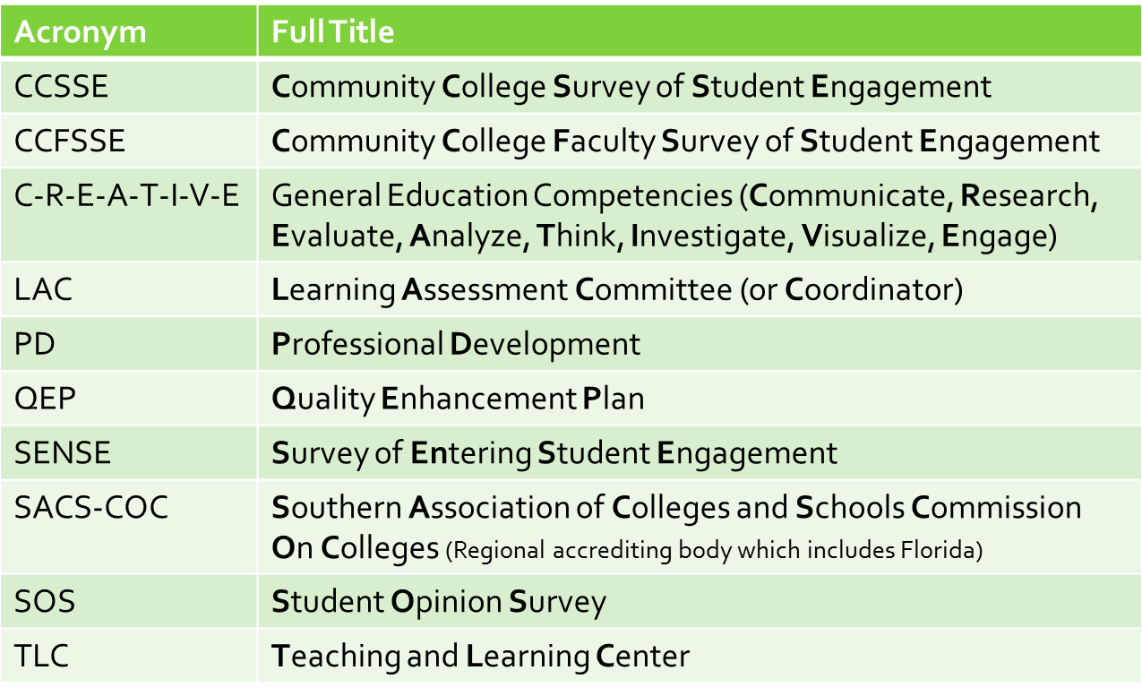
  - 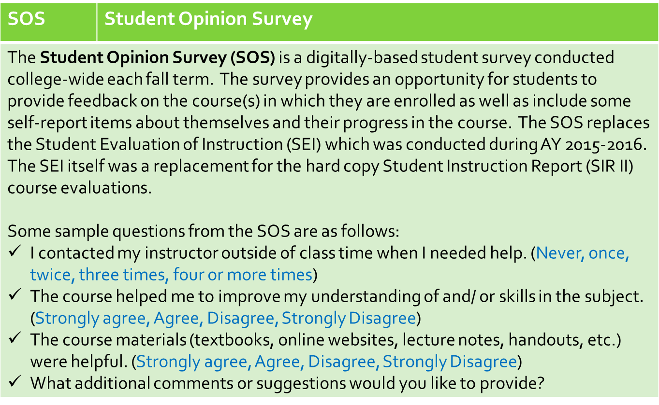
  - Richard Worch suggested we also prepare a video to teach faculty why we do assessment. Amy Trogan reported that additional videos may be necessary for the Assessment 101 Online workshop.
  - Committee agreed presenting these in total on the assessment webpage and including them as focal elements in upcoming newsletters would be beneficial.
- Based on comments above, Amy Trogan followed up with a proposal that the Assessment 101 Online Training be made a requirement for new Learning Assessment Committee (LAC) members. Jane Charles motioned this proposal, Megan Just seconded the motion. All approved.
- Amy Trogan also proposed a recommendation to the Professional Development Committee that the Assessment 101 Online Training be a requirement for new faculty training. Richard Worch motioned this proposed recommendation, Kristi Moran seconded the motion. All approved.
- No new business proposed by committee.
- Caroline Seefchak noted that the present meeting agenda included an incorrect upcoming LAC meeting date of February 2nd, when it should read February 3rd.
- Amy Trogan wished the committee a happy holiday break.

Richard Worch motioned to adjourn. Megan Just seconded.

