Learning Assessment Committee Meeting
3/3/2017
12:00 – 1:00
AA-177 (Lee Campus); E-105 (Charlotte Campus);
G-109 (Collier Campus)

Members Present: Eric Seelau, Amy Trogan , Joe Van Gaalen, Megan Just, Barbara Miley, Jane Charles, Richard Worch, Fernando Mayoral, Allison Studer, Lisa McGarity, Sarah Lublink, John Connell, Elijah Pritchett, Jennifer Patterson, Eric Fay, Eileen DeLuca, Katie Paschall, Rebecca, Harris, Margaret Kruger

Members Absent: Colleen Moore, Marty Ambrose, Tom Donaldson, Caroline Seefchak, Marius Coman, Kristi Moran

- A. Trogan called meeting to order (12:03pm)
- A. Trogan presented Feb. 3, 2017 meeting minutes. J. Connell motioned to approve minutes. R. Harris seconded the motion.
- J. van Gaalen presented the latest information on Course-level assessment.
  - 95 Course level assessments under analysis from Fall 2016; estimated completion data for course level studies still on target for the week of March 20, 2017 with exceptions for programs that asked for additional information to an already published report.
  - Speech & Foreign Languages, Social Sciences, Academic Success, English, Sciences, and Speech are complete as of Mar 1, 2017. Other programs and departments are in various stages of completion.
  - J. van Gaalen praised the Humanities Department for an innovative approach to course level assessment through the use of inter-program disposition questions administered as pre-test and post-test, which can then be used to compare how one course affects students compared with another from the same program.
- J. van Gaalen presented the latest information on GenEd assessment.
  - Calibration meetings went according to plan on Feb. 21, 22, and 24.
  - J. van Gaalen reviewed the General Education Competencies which have been assessed to this point since the new model began in AY 2014-2015 using current (updated for 2017) competencies:
    - AY 2015-2016: Communicate
    - AY 2016-2017: Evaluate & Think
- J. van Gaalen reminded the committee that it has been suggested over the course of the past academic year that the competency of Investigate and Research should be the focus for AY 2017-2018.
  - A. Trogan asked K. Paschall to open the floor on this discussion by sharing the rubric feedback she offered during a calibration meeting.
    - K. Paschall indicated that the AAC&U rubrics are good if the assignment is an essay of some type.
    - However, the rubric is not very applicable to other examples of assignments, even if the assignment is an excellent example for the competency.
  - A. Trogan posed the idea of developing new rubrics with the AAC&U as a foundation. To do this, some research may be necessary to develop the best rubrics to accommodate varying assignment types.
    - L. McGarity suggested asking for details from the assignment submitter.
    - E. DeLuca commented that in building from the old research to finalize a new rubric, we should consider creating a meta-rubric that would work across a variety of subjects. To do this, we may consider working backwards rather than forwards and proposed alterations for the Think or Communicate rubrics now that assignments typical of FSW have been reviewed in the context of AAC&U rubrics. Further, E. DeLuca suggested if the committee does intend to follow through with Investigate and Research then a pre-emptive look at the rubrics is what is necessary at this point.
    - R. Harris noted that at times two different rubrics (examples from AAC&U) may be necessary when working with assignments from one competency.
    - J. van Gaalen noted that the upcoming GenEd Feedback Workshop may help to further set up conversation towards revising the AAC&U rubrics from the most recent assessment (AY 2016-2017 GenEd Assessment).
    - E. DeLuca brought posed a possible new approach for GenEd sampling going forward by using courses which have been identified as representative of the competency as potential samples.
    - J. van Gaalen displayed the below donut plot to give the committee an idea of what students encounter going through a random version of a 60cr AA degree.
      - 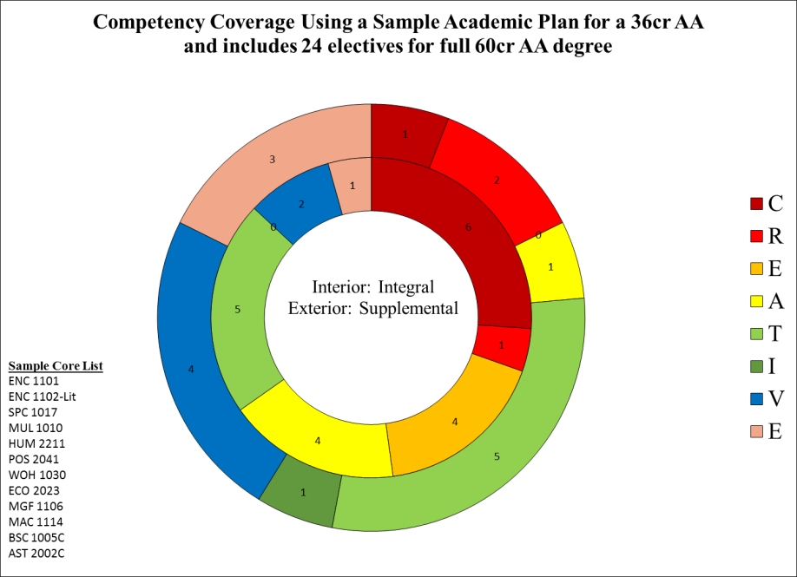
      - J. Charles and R. Harris note that updates or revisions of the identified competencies may still occur in the coming months as departments become more familiar with them and how they relate to their courses.
- A. Trogan addressed the content for the upcoming mini-newsletter for March:
  - Faculty/committee member spotlight
  - Professional development advertising
  - A. Trogan also noted she’d like to see the Humanities disposition results in the April newsletter.
- A. Trogan provided updates on the Assessment Certification initiative
  - A timeline has been developed for the Assessment 101 course as suggested in the February 2017 meeting; there has been a little more activity in the asynchronous Assessment 101 course since the timeline has been developed.
  - A. Trogan and J. van Gaalen are currently developing descriptions to workshops to make them clearer to non-assessment faculty and staff.
- J. Charles posed new business in terms of library instruction
  - J. Charles reported on a new workshop the library completed on plagiarism, which was very well received
  - J. Charles also reported on a second workshop on researching in mathematics, which was co-facilitated between math faculty and library staff. The participants found the transdisciplinary aspect of it to be fruitful as FSW moves forward with the new competencies.
  - M. Kruger noted the value in such a co-facilitated research workshop with the library for a variety of disciplines, including Community Health.

S. Lublink motioned to adjourn. R. Harris seconded.

