Uploading to Drop Box

Log into Drop Box: www.dropbox.com
User Name: curriculum@fsw.edu
Password: Curriculum (C is Capital)

When You Enter, Ignore the ‘Recent’ if there are any. Please do not place new files in this area. See Below.
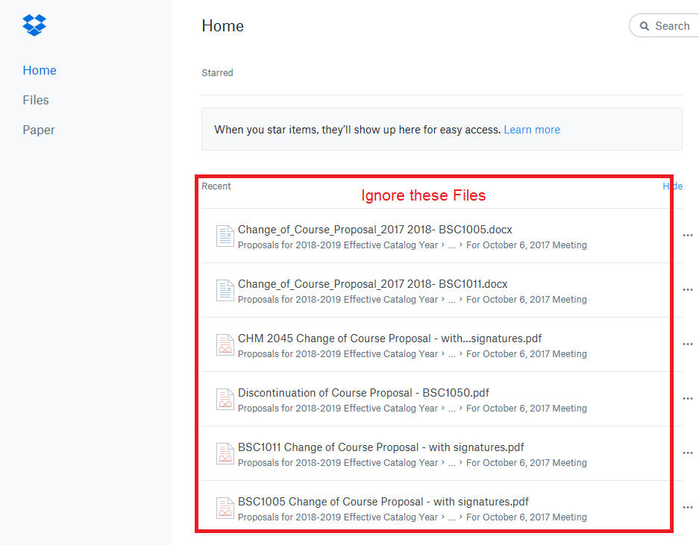
Click on Files
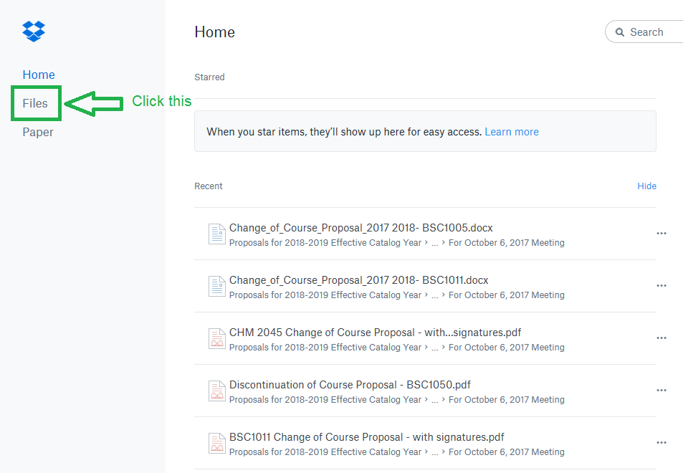

After getting to Files, Click into 1. Proposals for 2020-2021 Effective Catalog Year If you need the most updated/recent proposal forms, you can open that file below 1. Proposals for 2019-2020 Effective Catalog Year (see end for directions to download files).

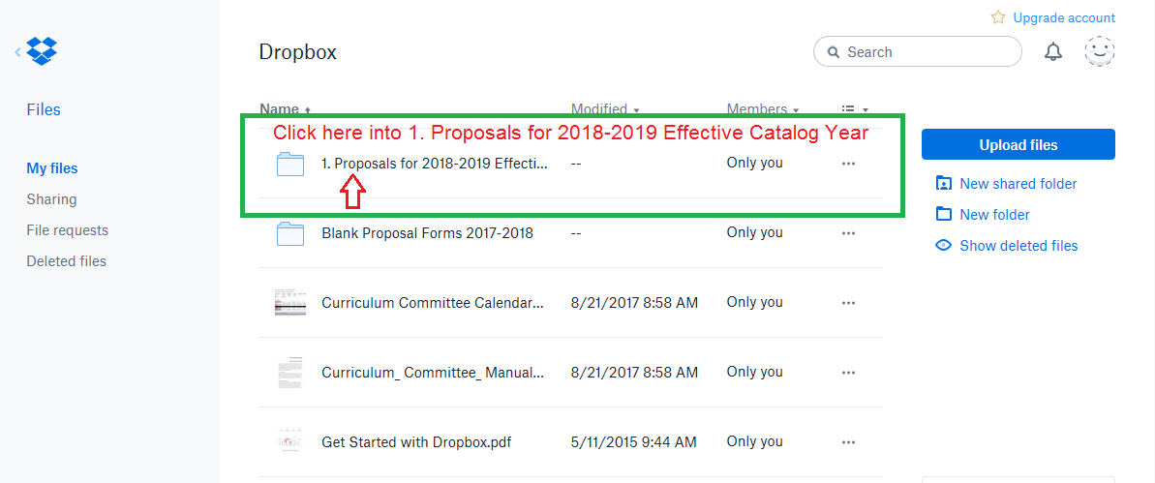
Once inside, find your School and Open File Location
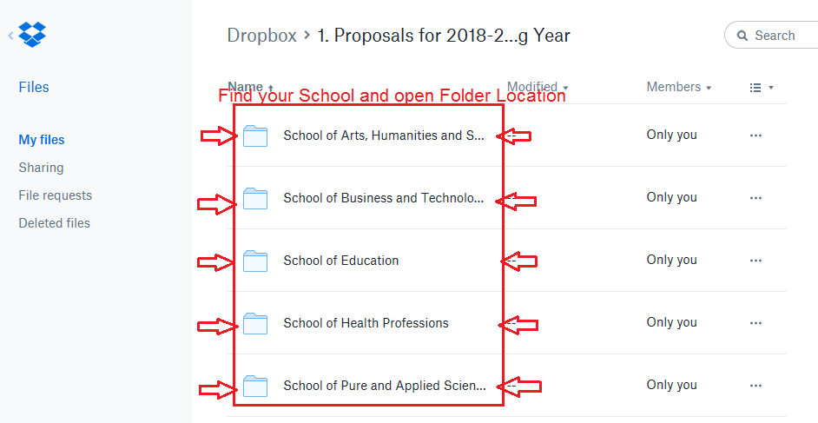

Inside your School Folder you will see the Folder for the upcoming meeting. Open this folder.

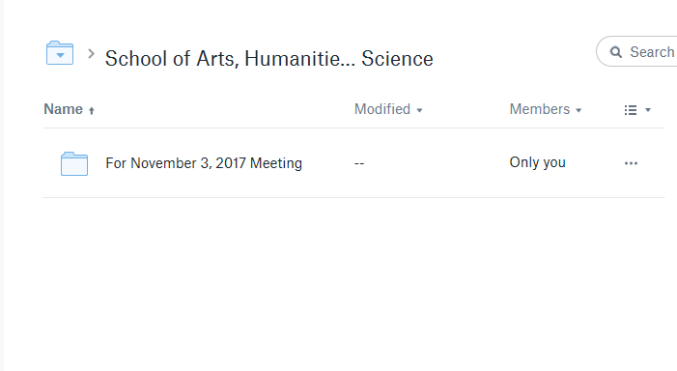
Once inside the folder, you can drag and drop your proposals inside
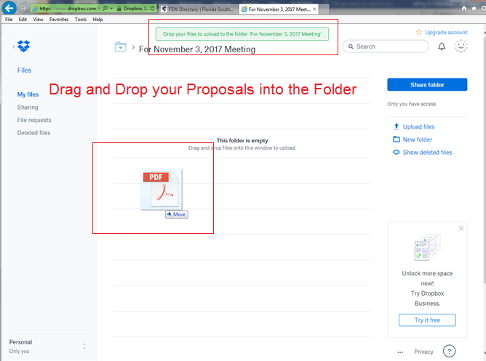

If you want to remove the file of a file that you just put in, make sure the check mark is checked to the left of the file, and click Delete.

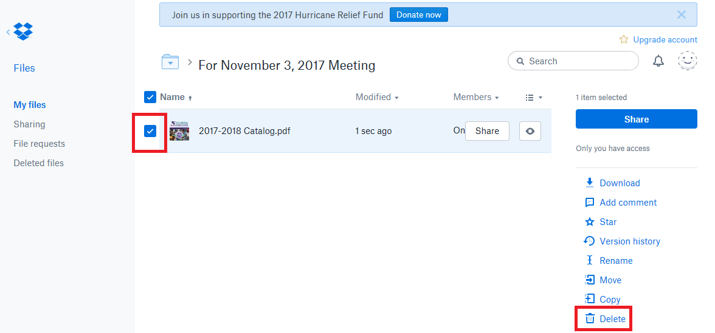

When you are done uploading files, click on the drop box symbol in the top left corner to bring you to the Home Page.

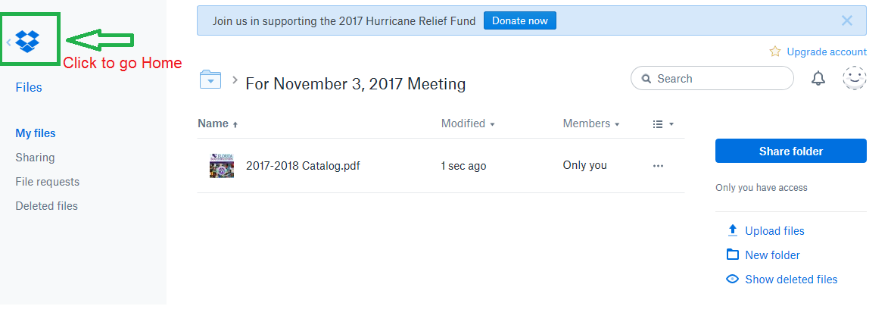

When you are on the home page, go to the top right and click on the smile face. This will drop down to give you the sign out option. Sign out and you are done.

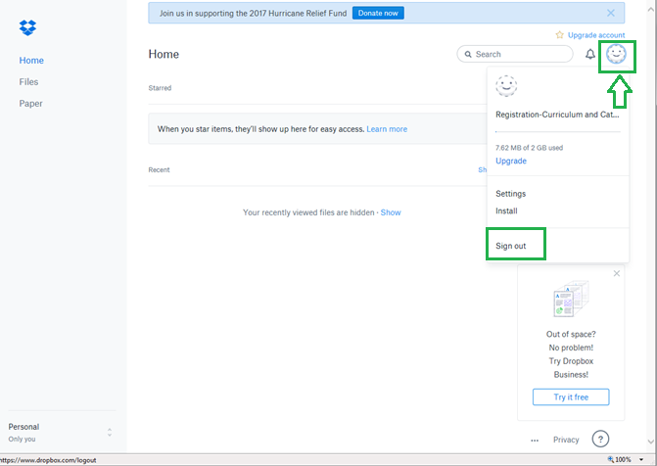

To Download Files
Make sure that the file you want is Blue Checked, then click Download.
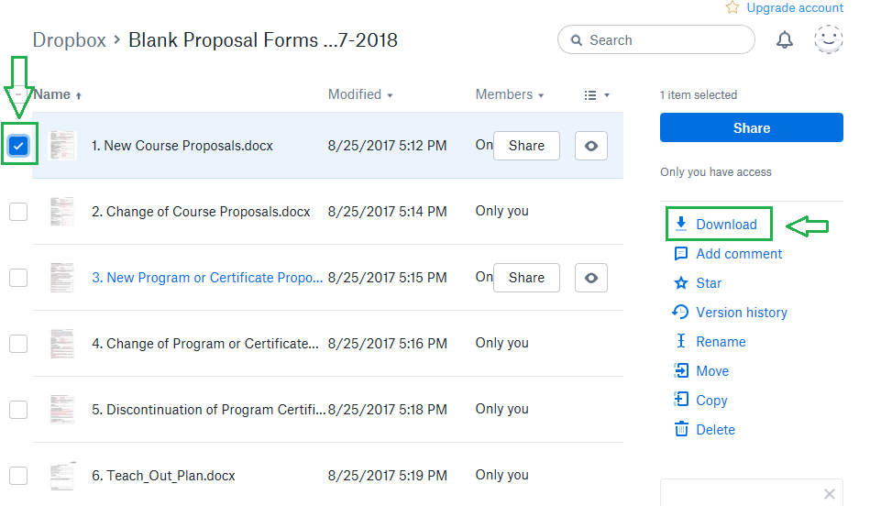

For Explorer, you will get this on the bottom of the page, click open. Once the file is open you can save to desk top fill out then drag and drop into you school file.
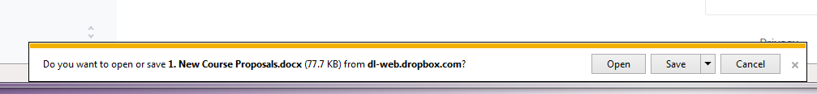

In FireFox, Save File, and click OK. Up top to your Download arrow and open the file then save to your desktop, fill in save then drag and drop into you school file.
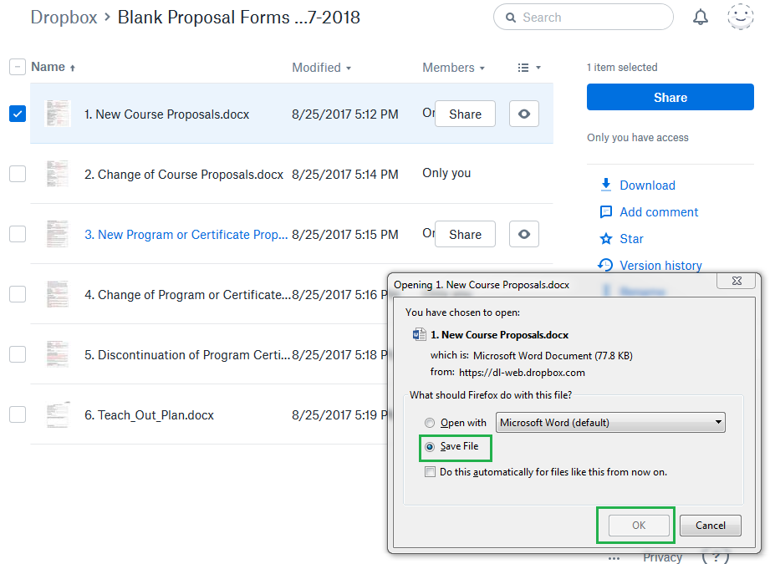
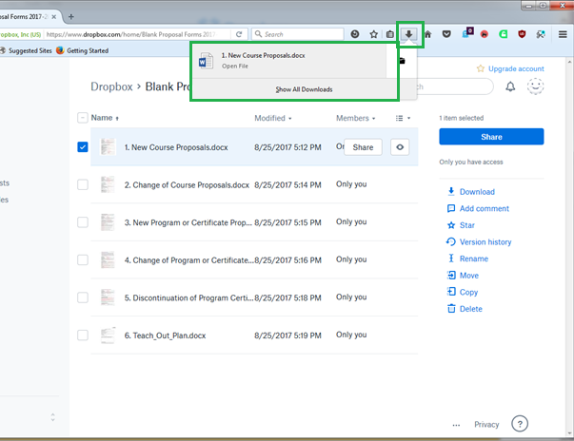

In Chrome, the file will appear in the Bottom Left Hand Corner, click on it and the document will open. (Enable Editing Mode) to fill in the form, save then drag-and-drop into you school file.

