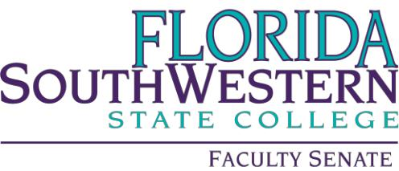

Learning Assessment Committee Meeting Minutes

Friday 12/01/2023
2:00 – 3:30 PM
Online via Zoom
Zoom - https://fsw.zoom.us/j/89390117484

Attendees: Jennifer Patterson, Joseph van Gaalen, Jane Charles, Amy Trogan, Meghan Carlson, Jennifer Summary, Caroline Seefchak, Richard Worch, Krissy Cabral, Veronica Ruiz, Jessica Godwin, Eric Seelau, Tommy Mann (Rep. for Tami Such), Renee Hester, Susan Foster, Mary Conwell, Tom Donaldson

Agenda

- Introductions/Opening
  - Meeting started at 2pm
  - November meeting minutes approved with edits
- DataVersed updates
  - Two issues per semester
  - Feb/March issues expected
  - Call for article ideas
    - Announce new LAC mission statement
    - Classroom assessment techniques (CAT) article for next issue
    - Feature piece called What a Change: idea to approach colleagues and ask “did you make any changes to your class this semester?”
    - Continue advertising Assessment 101
    - Include comment from those who have completed assessment 101
- Assessment 101 updates
  - Possibly revitalizing the course (increasing enrollment)
  - Encouraging those not directly involved in assessment to take the course
- Discuss any progress for the GenEd review of assignments
  - No new updates
  - Touch back on it in the Spring semester
- Breakout groups:
  - Writing effective learning outcomes
    - Taking SLOs to the next level
    - Bloom’s taxonomy is beneficial for SLO
      - Poorly written SLOs are not measurable, but Bloom’s can help keep you on track when writing them
  - Alignment of assessments with outcomes
    - Series of workshops or mini workshops each focusing on one area of assessment such as rubrics and how to align them to objectives
  - Connecting coordinator feedback with workshops
    - Touching base with the ECs
    - Detailed a conversation with an Effectiveness Coordinator: using AI for assessment, specifically for developing a pre and post test
- New Business
  - No new business
- Meeting ended at 2:35

